LLD – MSME FD/RD

Test Plan Approach and
IBM Corporation

Authors
Name | Role in IBM Project
Akanksha Hitendra Kore | Application Developer

Document History
Date | Version | Document Revision Description | Document Author
29-Jan-25 | 1.0 |  | Akanksha Hitendra Kore

Term Deposit Context Diagram

A context diagram provides a high-level view of the system and its interactions with external entities. In this scenario, the system interacts with various external entities to perform the described tasks. Here's a context diagram for the given scenario:

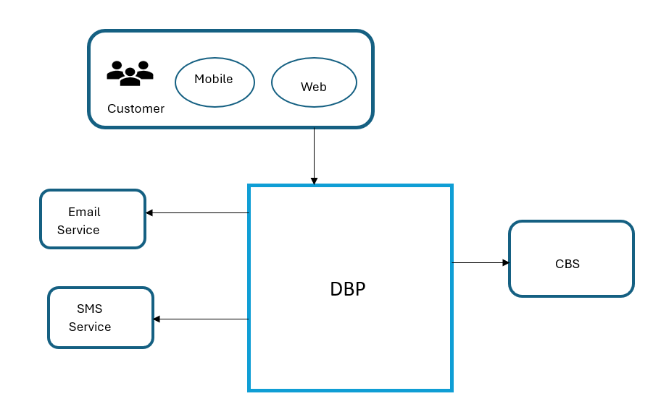
In this diagram:

The "Finacle CBS" is the main system that performs the described tasks.
External entities include "Customer Records", "Staff Status", "Accounts Record", "Current Account Nominee .
The system interacts with these entities to fulfill tasks such as fetching customer records, checking staff status, checking account records, fetching CA and OD account nominees, performing maturity calculations,and opening and closing term deposits.
This context diagram gives a high-level overview of the system's interactions with external entities without delving into the internal processes of the system itself.

Process Flow

A process flow is a visual representation or diagram that outlines the sequential steps involved in completing a particular task or process. It provides a structured overview of how activities are interconnected and the order in which they occur.

Fetch Customer Records:

Obtain customer details such as PAN (Permanent Account Number), email ID, and address from the database.
Check Staff Status (Customer Record):

Determine if the customer is a staff member or associated with the institution. This step might involve accessing a specific database or flag indicating staff status.
Check Accounts Record:

Review the customer's account records to verify their status:
Dormant: Determine if any accounts associated with the customer are dormant.
Frozen: Check if any accounts are frozen due to legal or administrative reasons.
LIEN marked: Verify if any accounts have a lien marked against them.
Fetch CAA Account Nominee:

If applicable, retrieve details of the nominee associated with the current (SB) account.
Maturity Calculation:

If there are fixed deposits (FDs) associated with the customer, calculate their maturity date. This step may involve considering the deposit term and any applicable interest rates.
Open FD:

If necessary, initiate the process to open a fixed deposit account for the customer.
Close FD:

If any existing fixed deposits need closure, proceed with the necessary steps to close them.
Download Certificate:

Generate and download certificates related to any transactions or account activities performed during this process. This could include FD certificates, KYC confirmation documents, etc.
Authenticate Transaction Basis TPIN:

Ensure that all transactions and actions performed are authenticated securely. This might involve using a Transaction Personal Identification Number (TPIN) or another authentication method.
This process flow covers the essential steps involved in checking the KYC status of a customer, assessing account statuses, managing deposits, and ensuring the security of transactions through authentication. Each step should be executed accurately and securely to maintain compliance and customer satisfaction.
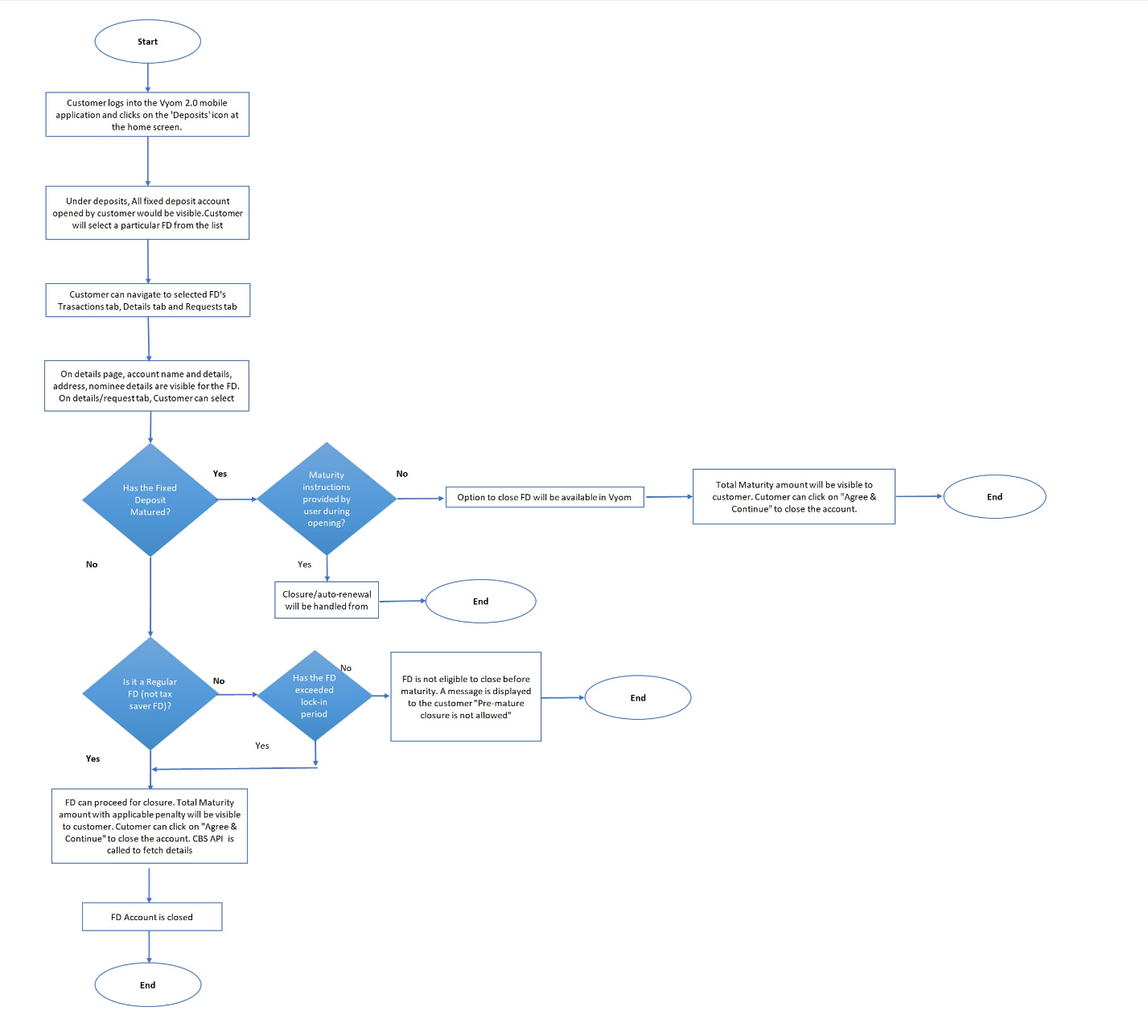

Component Diagram for Term Deposit (FD and RD)

A Component Diagram for a Term Deposit (FD and RD) System illustrates the various components and their interactions within the system.

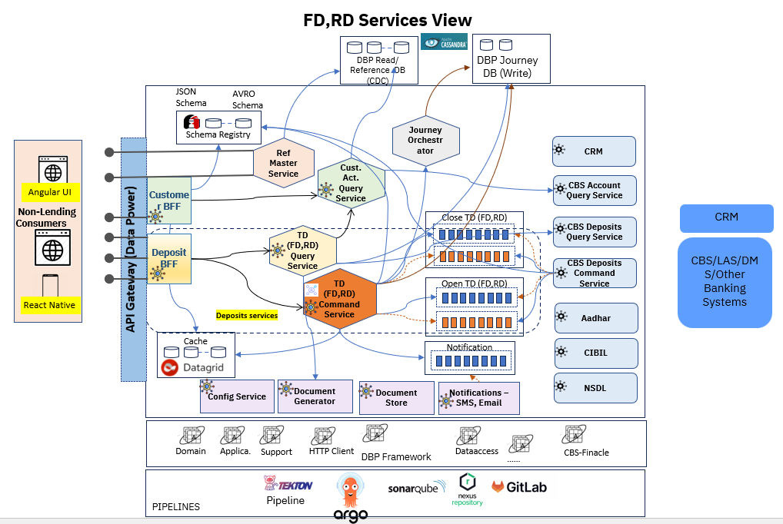

Following Components are involved in for Term Deposit Services
      - BFF Services
        - Deposit BFF for Mobile : provides interfaces for Mobile and interact with TD Business Microservices. It performs input model level validations (Data Sanity Checks) pertained to Term Deposit. It also also fetch data from Cache for sending status to Frontent while opening a Term Deposit.
      - Business MicroServices
        - Term Deposit Query Service :
- Fetch TD Detail from CBS via proxy and Local CDC DB. It also aggregates messages received from both sources.
- Perform Status of an Term Deposit.
- Download various documents.
        - Term Deposit Command Service:
  - This component contains all Term Deposit Domain entities, Events, Value objects and Term Deposit Business rules implementation which is part of Domain Entities.
  - Journey Orchestrator (JO) is part of a command service of DBP platform, JO service for TD performs managing the state events of a Term Deposit application form in Draft, Pending and Complete states.
  - Save a Term Deposit – When Term Deposit Application is requested, it will be saved to local DBP DB. The Journey Orchestatro will maintain the state of application in “Draft” mode.
  - Submit a Term Deposit – when a user requests for opening a Term Deposit, post validation of Term Deposit Domain Business Validation / Rules, it saves Term Deposit in Pending state and pushes application to CBS via Kafka. It also sends back status as “Pending” to user/frontent application along with an unique transaction reference number. The status is also stored in Cache (RHDG) by the same unique transaction reference number.
  - The Listener will process the response message received from CBS and update status in Cache as well. When there is an error message received, status will be updated as “FAIL” in cache with an adequate failed reasone. The state will be turned to “Draft” on an error messages otherwise status will be “SUCCESS” with state as “COMPLETEE”.
Below Diaram illustrates inner resource type of Command and Query services.

State | Status
Draft | SUCCESS | When application is first saved
Pending | PENDING | When application is submitted. And Sent to CBS to openig or closing the Term Deposit.
Draft | FAIL | When application response received from CBS as “FAIL” due to some reason at CBS side
COMPLETE | SUCCESS | The application is completed successfully.

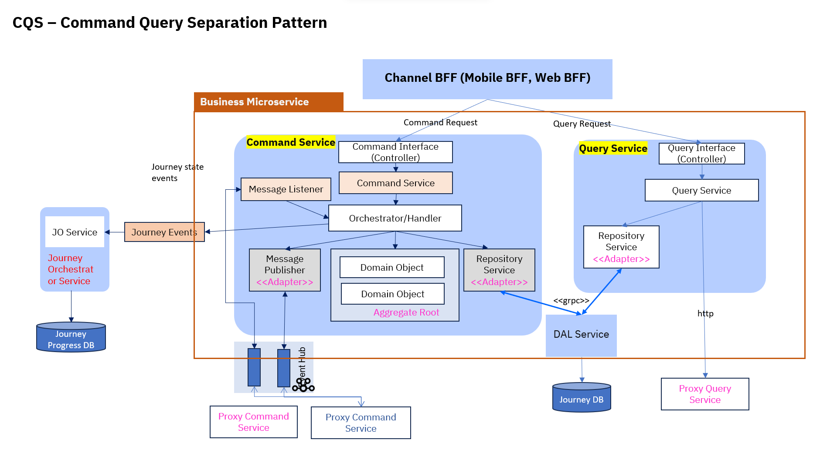
      - Proxy Service
        - CBS Deposit Query Service
        - CBS Deposit Command Service

Following Components are horizontal components required for Term Deposit Service.
  - Customer Query Service
  - JO (Journey Orchestrator)
  - Proxy Services

Use Case Realization - Sequence Diagram

Below Sequence Flow provides detail about various use cases for Term Deposit Command Call –

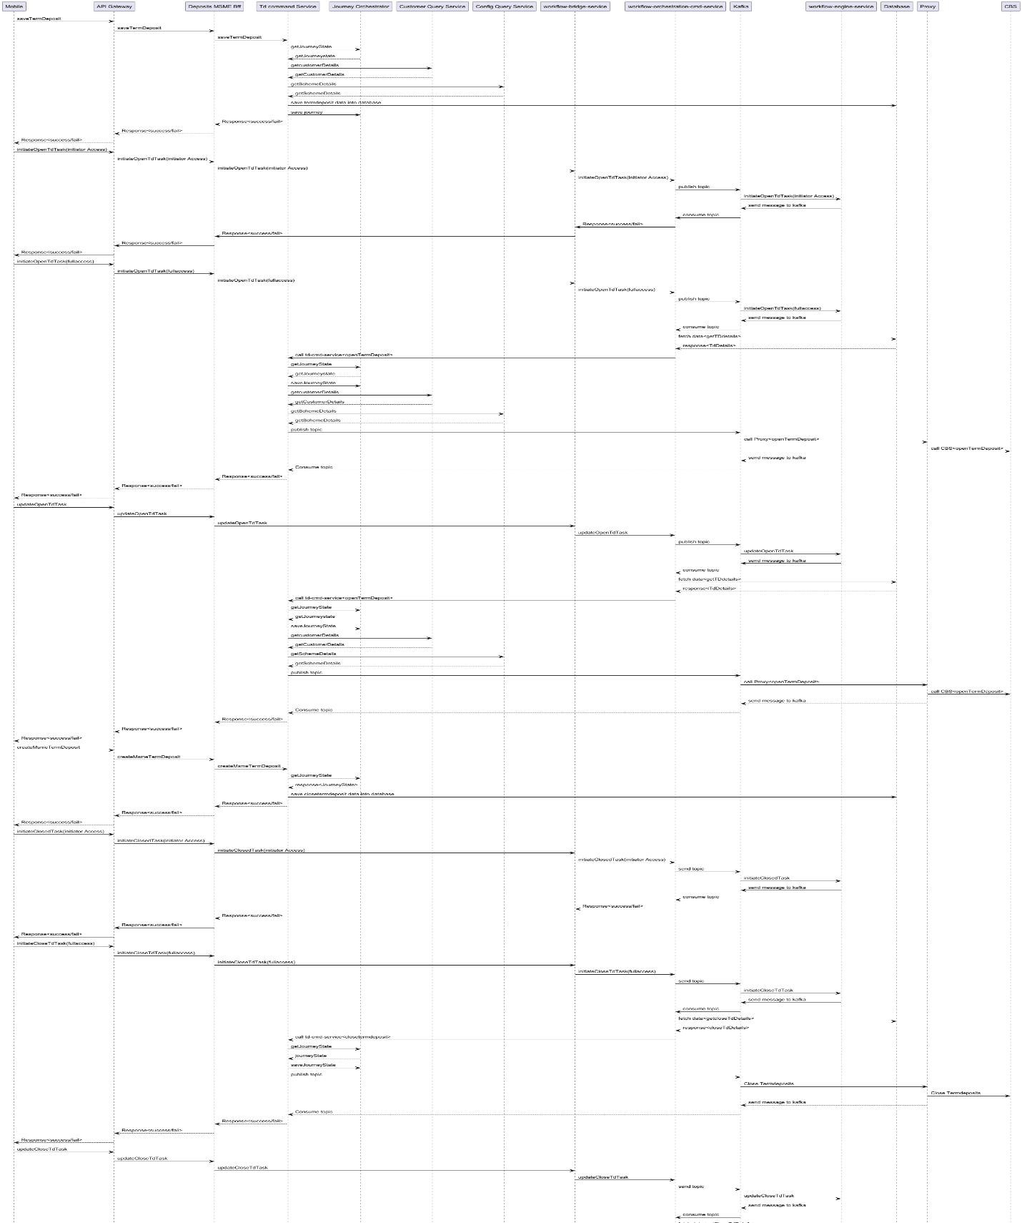

Below Sequence Flow provides detail about various use cases for Term Deposit Query Call –

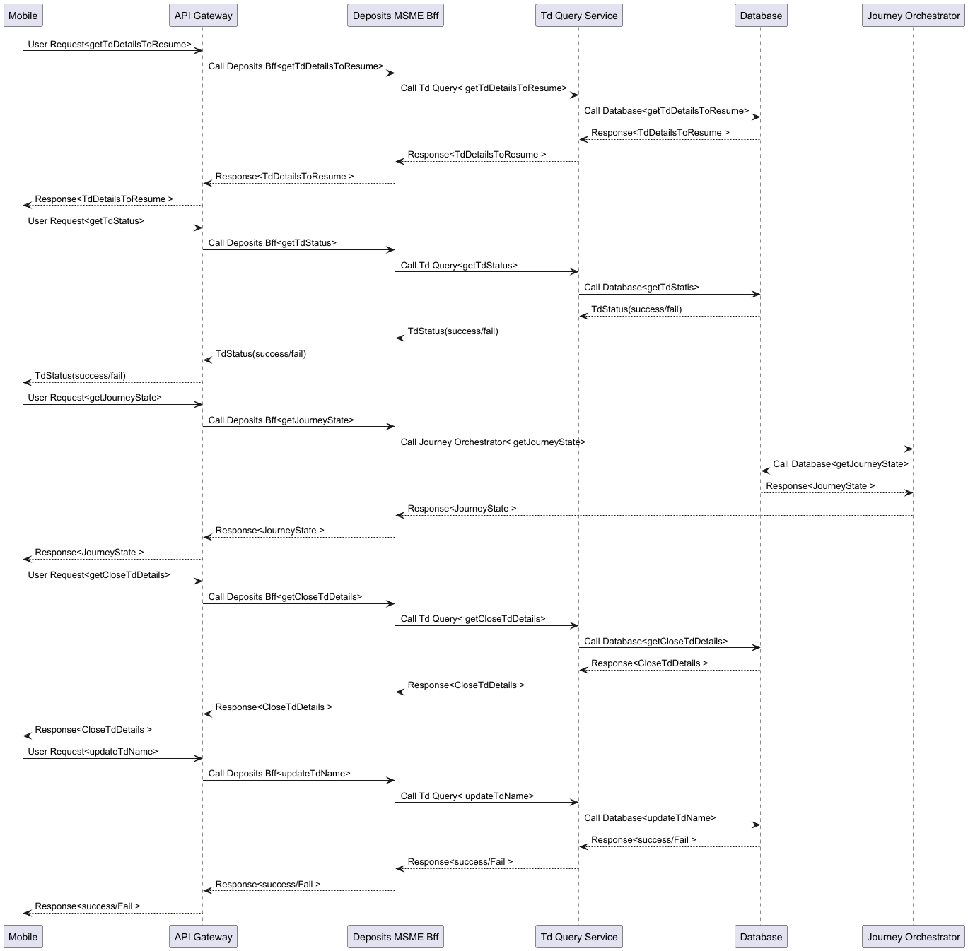

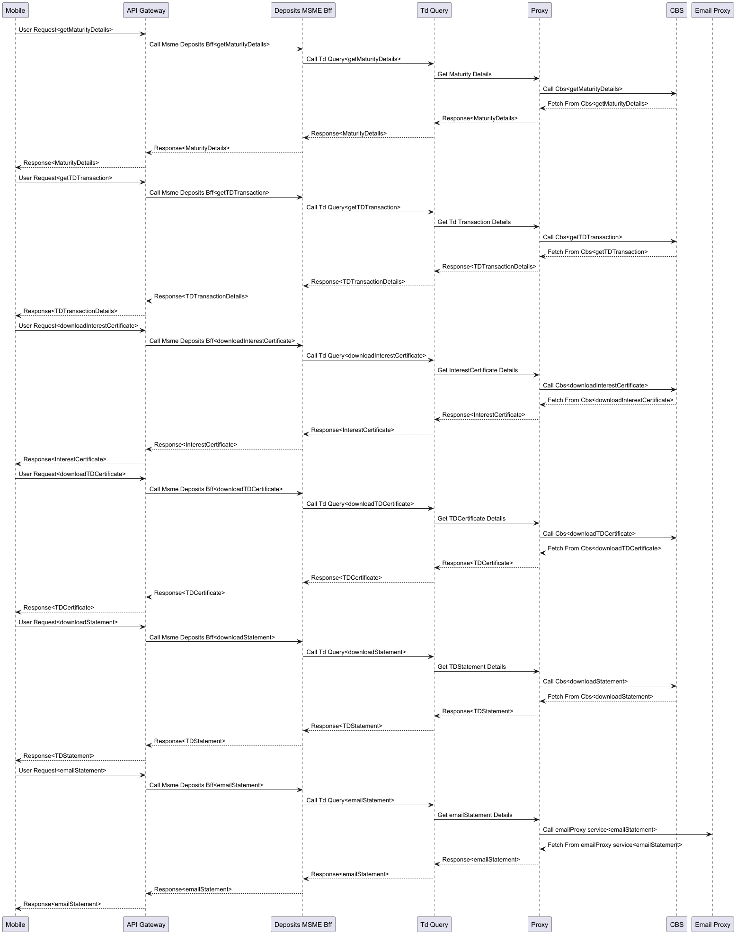
Term Deposit Domain | Term Deposit Domain Component performs following business rule.  - Minimum and Maximum Deposit Amount checks based on scheme lookup.  - Minimum and Maximum tenure based on scheme lookup.
Nominee Domain | If Nominee age is below 18 then Gaudian info is required  If Guardian is available, addressLine1 and AddressLine2 should be available.  Nominee and Guardian address should not be exceeding 84 characters.
Customer Domain | Customer should have valid Pan
Account Domain | Customer Should have valid CASaccount to open Term Deposit.  CASA should have Active CA account.
Term Deposit Domain Entity and Domain Validations (Business Validations)

Term Deposit Domain Events
Create Term Deposit | Allow to create Term Deposit locally.
Creating Term Deposit | When Term Deposit pushed to Kafka for opening the Term Deposit.
Created Term Deposit | When Term Deposit Created
Close Term Deposit | When Term Deposit Close
Error Message
Error Code | Error Message
TERM_DEPOSIT_NOT_INIT | Term Deposit is not initialized
CUST_KYC_NOT_INIT | Customer kyc not initialized or empty
SCHEME_NOT_INIT | Scheme is not initialized or empty
CUST_NOT_FOUND | Customer is not available or invalid
CUST_NOT_INIT | Customer id is not initialized or empty
CUST_DOB_NOT_AVAILABLE | Customer DOB is not available
CUST_NOT_AVAILABLE | Customer id is not initialized empty
NO_APPS_FORM_NUM | Application form number is empty or invalid
ACCT_NOT_INIT | ACCOUNT is not initialized
ACCT_NOT_AVAILABLE | ACCOUNT is not available or invalid
SCHEME_NOT_FOUND | SCHEME is not available for given details
SCHEME_TYPE_NOT_FOUND | Subtype or SubTypeCode is not initialized or empty
SCHEME_DETAIL_NOT_PROVIDED | SCHEME details not provided
KYC_STATUS_ACTIVE | KYC Status is in ACTIVE
KYC_STATUS_INACTIVE | KYC Status is in INACTIVE
SAVE_DATA | Unable to Process your request
CUST_KYC_NOT_AVAILABLE | Customer's KYC status is not available or not valid
CUST_KYC_VALIDITY_EXPIRED | Customer's KYC status is expired
CUST_KYC_INVALID_PAN | Customer's PAN is empty or invalid
CUST_KYC_INVALID_AADHAR | Customer's Aadhar is empty or invalid
TERM_DEPOSIT_NOT_FOUND_WITH_FRM_NUM | No Term deposit found for the provided CIF and Application Form Number
TERM_DEPOSIT_NOT_FOUND_WITH_ACCT_NUM | No Term deposit found for the provided CIF and Account Number
EMPTY_ACC_OR_DEPOSIT | Deposit or Source Account is empty
EMPTY_SCHEME | Scheme is empty or invalid
ACCOUNT_NOT_CASA | Account is not valid CASA
ACCOUNT_NOT_VALID | Account is not valid
TERM_DEPOSIT_NOT_PERSIST | Unable to persist TermDeposit
TERM_DEPOSIT_NOT_NOMINEE_PERSIST | Unable to persist TermDeposit Nominee
TERM_DEPOSIT_MAPPING_ISSUE | Unable to Map TermDepositDomain to TermDeposit
TERM_DEPOSIT_NOT_UPDATE | Unable to update TermDeposit
TERM_DEPOSIT_NOT_NOMINEE_UPDATE | Unable to update TermDeposit Nominee
DEPOSIT_NOT_IN_DRAFT | Deposit should be in draft state before opening it
DEPOSIT_NOT_IN_PENDING | Deposit should be in pending state before completing
DEPOSIT_STATE_NOT_VALID | Deposit is not in correct state to initialize
MATURITY_INSTRUCTION_ENUM_NOT_VALID | Maturity Instrunction is not Valid value
SUBTYPE_INVALID | Subtype is not Valid value
INTEREST_PAYOUT_INVALID | InterestPayout Type is not Valid value
MATURITY_INDICATOR_ENUM_NOT_VALID | Maturity Indicator is not Valid value
RENEWALDTLS_NOT_PRESENT | RenewalDtls not available or invalid
DEPOSIT_NOT_INIT | Deposit is not initialized!
DEPOSIT_ZERO_MONEY | Deposit is not initialized!
DEPOSIT_CIF_NOT_FOUND | Deposit cif is not provide or invalid
DEPOSIT_CIF_AND_SOURCE_CIF_NOT_FOUND | Deposit cif and source cif issue should be same for Sole_Ownership
DEPOSIT_AGE | Age is less than %s
DEPOSIT_NOMINEE_AGE | Nominee age is less than %s
DEPOSIT_MONEY_INVALID | Deposit Money is invalid Mulitplier issue
DEPOSIT_INT_RATE_INVALID | Interest Rate is negative or invalid
DEPOSIT_TERM_INVALID | Deposit term is negative or invalid
DEPOSIT_MIN_MAX_ALLOWED_AMT | Deposit Amount should be greater than or equal to %s and less than %s
DEPOSIT_DAYS_ALLOWED | Deposit days should be less than or equal %s
NOMINEE_UPDATE_NOT_AVAILABLE | Nominee detail not available
DEPOSIT_INVALID | Deposit does not exist to create
MINOR_GUARDIAN_NOT_AVAILABLE | Minor's Guardian detail not available
NOMINEE_ADDRESS_NOT_AVAILABLE | Address addressLine1 not available
NOMINEE_ADDRESS_MAX_LENGTH | Nominee address should be maximum 84 character long
MINOR_GUARDIAN_CONTACTINFO_NOT_AVAILABLE | Minor's Guardian Contact detail not available
Data Base Tables
TableName | Column Name | Column Comment | Key | Data Type | DATA_LENGTH
customer | cif | Customer CIF | K | text | 50
customer | first_name | Customer First Name |  | text | 80
customer | middle_name | Customer Middle Name |  | text | 80
customer | last_name | Customer Last Name |  | text | 80
customer | id | System Generated Unique Identfier Key |  | uuid
customer | date_of_birth | Date Of birth of Customer |  | timestamp
customer | pan_number | PAN Number of Customer |  | text | 10
customer | national_id_number | National identity Number |  | text | 20
customer | gender_id | Gender System Generated Unique Identfier Key ( From Common Reference Master Table ) |  | text | 128
customer | gender | Gender of Customer ( Male/Female ) ( From Common Reference Master Table ) |  | text | 11
customer | seniorcitizen_flag | Flag for Senior Citizen ( Y/N ) |  | boolean | 1
customer | superseniorcitizen_flag | Flag for Super Senior Citizen ( Y/N ) |  | boolean | 1
customer | kyc_compliant_flag | Flag for KYC Compliant ( Y/N ) |  | boolean | 1
customer | kyc_validity_date | kyc validity date |  | timestamp
customer | kyc_date | Date on which KYC is done |  | timestamp
customer | rekyc_compliant_flag | Flag for ReKYC Compliant ( Y/N ) |  | boolean | 1
customer | rekyc_date | Date on which ReKYC is done |  | timestamp
customer | pan_aadhar_linked_flag | Flag for PAN and Aadhar Linked ( Y/N ) |  | boolean | 1
customer | mobile_number | Mobile Number of Customer |  | text | 16
customer | email_address | Email Address of Customer |  | text | 50
customer | occupation | Occupation of Customer ( Salaried ) |  | text | 80
customer | branch_code | Branch Code |  | text | 6
customer | branch_name | Name of the Branch |  | text | 30
customer | branch_id | Branch System Generated Unique Identfier Key |  | text | 128
customer | branch_addressline1 | Address Line1 of Branch |  | text | 45
customer | branch_addressline2 | Address Line2 of Branch |  | text | 45
customer | branch_addressline3 | Address Line3 of Branch |  | text | 45
customer | branch_addressline4 | Address Line4 of Branch |  | text | 45
customer | branch_address_pincode | PinCode of Branch Address |  | text | 10
customer | branch_postoffice | PostOffice Name of the Branch |  | text | 45
customer | branch_city_id | City System Generated Unique Identfier Key |  | text | 128
customer | branch_city | City of Branch |  | text | 45
customer | branch_district_id | District System Generated Unique Identfier Key |  | text | 128
customer | branch_district | District of Branch |  | text | 45
customer | branch_sub_district | Sub District of Branch |  | text | 45
customer | branch_state_id | State System Generated Unique Identfier Key |  | text | 128
customer | branch_state | State of Branch |  | text | 30
customer | branch_working_hrs | Working Hrs of branch (10:00am to 4:00am, Mon to Sat,1st,3rd and 5th Sat |  | text | 50
customer | active_flag | Active Flag, Record is active or logically deactivated Y/N |  | boolean | 1
customer | created_date | Date on which record is Inserted |  | timestamp
customer | created_by | Job/ETL/Service name through which record is Inserted |  | text | 50
customer | modified_date | Date on which record is Modified |  | timestamp
customer | modified_by | Job/ETL/Service name through which record is Modified |  | text | 50
customer | channel | Channel Name ( Mobile Name,WebApp) |  | text | 20
term_deposit_account | cif | Customer CIF | K | text | 50
term_deposit_account | application_form_number | Application Form Number | C ^ | text | 20
term_deposit_account | account_number | FD or RD Account number of a customer |  | text | 16
term_deposit_account | trans_ref_number | Transaction Reference Number |  | text | 20
term_deposit_account | customer_id | Customer System Generated Unique Identfier Key |  | text | 128
term_deposit_account | scheme_id | Scheme System Generated Unique Identfier Key |  | text | 128
term_deposit_account | source_account_id | CA/SA/OD Account Id Select to create FD |  | text | 128
term_deposit_account | source_account_name | CA/SA/OD Account Name Select to create FD |  | text | 80
term_deposit_account | name | Name of an Account |  | text | 80
term_deposit_account | opening_date | Opening Date of an Account |  | timestamp
term_deposit_account | subscription_code | Subscription Code ( FD,RD) |  | text | 5
term_deposit_account | scheme_code | Scheme Code |  | text | 16
term_deposit_account | scheme_name | Scheme Name |  | text | 50
term_deposit_account | interest_rate | Interest Rate of |  | decimal | 9
term_deposit_account | tenure_days | Tenure Days |  | int
term_deposit_account | tenure_months | Tenure Months |  | int
term_deposit_account | tenure_years | Tenure Years |  | int
term_deposit_account | deposit_amount | Initial Amount deposited at the time of FD or RD Creation |  | decimal | 20
term_deposit_account | interest_payout | Interest Payout |  | text | 20
term_deposit_account | interest_amount_value | Interest Value |  | decimal | 20
term_deposit_account | maturity_date | Maturity Date Of Account |  | timestamp
term_deposit_account | maturity_amount | Maturity Amount Of Account |  | decimal | 20
term_deposit_account | maturity_indicator | Indicator of Maturity (Close on Maturiy/Auto Renewal with Principle Amount/Auto Renewal with Principle and Interest Amount ) |  | text | 30
term_deposit_account | maturity_instruction | Maturity Instruction ( Principle / Principle+Interest) |  | text | 20
term_deposit_account | rd_si_startdate | Start Date of Recurring for Standing Instruction |  | timestamp
term_deposit_account | operating_instruction | Operating Instruction (Single,Either or Survivor or Operated by natural Guardian) |  | text | 20
term_deposit_account | selfminor_indicator | Account Indicator ( Self- Yes/Minor- No) |  | boolean | 1
term_deposit_account | declaration_indicator | Account Declaration (Y/N) |  | boolean | 1
term_deposit_account | declaration_date | Account Declaration Date |  | timestamp
term_deposit_account | tds_form | TDS form 15G/15H submitted by customer |  | text | 5
term_deposit_account | rd_tax_saving_indicator | Tax Saving Indicator ( Y/N) |  | boolean | 1
term_deposit_account | opening_acceptance | Account Opening Term and Consition Accept-Y/Reject-N |  | boolean | 1
term_deposit_account | premature_closing_acceptance | Account Prematurity Closing Term and Consition Accept-Y/Reject-N |  | boolean | 1
term_deposit_account | closing_acceptance | Account Closing Term and Consition Accept-Y/Reject-N |  | boolean | 1
term_deposit_account | notification_indicator | Account Open/Closing Notification Indicator Y/N |  | boolean | 1
term_deposit_account | status | Status Of an Account Creation ( Complete/Incomplete/Closed/Withdrawal) |  | text | 20
term_deposit_account | active_flag | Active Flag, Record is active or logically deactivated Y/N |  | boolean | 1
term_deposit_account | created_date | Date on which record is Inserted |  | timestamp
term_deposit_account | created_by | Job/ETL/Service name through which record is Inserted |  | text | 50
term_deposit_account | modified_date | Date on which record is Modified |  | timestamp
term_deposit_account | modified_by | Job/ETL/Service name through which record is Modified |  | text | 50
term_deposit_account | channel | Channel Name ( Mobile Name,WebApp) |  | text | 20
term_deposit_nominee | cif | Customer CIF | K | text | 50
term_deposit_nominee | application_form_number | Application Form Number | C ^ | text | 20
term_deposit_nominee | first_name | First Name of Nominee for Account | C ^ | text | 80
term_deposit_nominee | middle_name | Middle Name of Nominee for Account |  | text | 80
term_deposit_nominee | last_name | Last Name of Nominee for Account |  | text | 80
term_deposit_nominee | account_number | PPF Account number of a customer |  | text | 16
term_deposit_nominee | trans_ref_number | Transaction Reference Number |  | text | 20
term_deposit_nominee | account_id | Account System Generated Unique Identfier Key |  | text | 128
term_deposit_nominee | customer_id | Customer System Generated Unique Identfier Key |  | text | 128
term_deposit_nominee | relationship_id | Relationship System Generated Unique Identfier Key from Common Reference Table |  | text | 128
term_deposit_nominee | relationship | Nominee Relationship ( From Common Reference Master Table ) |  | text | 20
term_deposit_nominee | age | Age of Nominee for Account |  | int
term_deposit_nominee | date_of_birth | Date Of Birth of nominee |  | timestamp
term_deposit_nominee | addressline1 | Address Line1 of FD or RD Account Nominee |  | text | 45
term_deposit_nominee | addressline2 | Address Line2 of FD or RD Account Nominee |  | text | 45
term_deposit_nominee | addressline3 | Address Line3 of FD or RD Account Nominee |  | text | 45
term_deposit_nominee | addressline4 | Address Line4 of FD or RD Account Nominee |  | text | 45
term_deposit_nominee | address_pincode | PinCode of FD or RD Account Nominee Address |  | text | 6
term_deposit_nominee | city_id | City System Generated Unique Identfier Key |  | text | 128
term_deposit_nominee | city | City of FD or RD Account Nominee |  | text | 45
term_deposit_nominee | district_id | District System Generated Unique Identfier Key |  | text | 128
term_deposit_nominee | district | District of FD or RD Account Nominee |  | text | 45
term_deposit_nominee | state_id | State System Generated Unique Identfier Key |  | text | 128
term_deposit_nominee | state | State of FD or RD Account Nominee |  | text | 30
term_deposit_nominee | minor_flag | Flag for Nominee is Minor ( Y/N ) |  | boolean | 1
term_deposit_nominee | guardian_relationship_id | Relationship System Generated Unique Identfier Key from Common Reference Table |  | text | 128
term_deposit_nominee | guardian_relationship | Nominee Gaurdian Relationship ( From Common Reference Master Table ) |  | text | 20
term_deposit_nominee | guardian_first_name | First Name of Guardian of Nominee for an Account |  | text | 80
term_deposit_nominee | guardian_middle_name | Middle Name of Guardian of Nominee for an Account |  | text | 80
term_deposit_nominee | guardian_last_name | Last Name of Guardian of Nominee for an Account |  | text | 80
term_deposit_nominee | guardian_age | Age of Guardian of Nominee for an Account |  | int
term_deposit_nominee | guardian_addressline1 | Address Line1 of FD or RD Account Nominee Guardian |  | text | 45
term_deposit_nominee | guardian_addressline2 | Address Line2 of FD or RD Account Nominee Guardian |  | text | 45
term_deposit_nominee | guardian_addressline3 | Address Line3 of FD or RD Account Nominee Guardian |  | text | 45
term_deposit_nominee | guardian_addressline4 | Address Line4 of FD or RD Account Nominee Guardian |  | text | 45
term_deposit_nominee | guardian_address_pincode | PinCode of FD or RD Account Nominee Guardian Address |  | text | 6
term_deposit_nominee | guardian_city_id | City System Generated Unique Identfier Key |  | text | 128
term_deposit_nominee | guardian_city | City of FD or RD Account Nominee Guardian |  | text | 45
term_deposit_nominee | guardian_district_id | District System Generated Unique Identfier Key |  | text | 128
term_deposit_nominee | guardian_district | District of FD or RD Account Nominee Guardian |  | text | 45
term_deposit_nominee | guardian_stateId | State System Generated Unique Identfier Key |  | text | 128
term_deposit_nominee | guardian_state | State of FD or RD Account Nominee Guardian |  | text | 30
term_deposit_nominee | active_flag | Active Flag, Record is active or logically deactivated Y/N |  | boolean | 1
term_deposit_nominee | created_date | Date on which record is Inserted |  | timestamp
term_deposit_nominee | created_by | Job/ETL/Service name through which record is Inserted |  | text | 50
term_deposit_nominee | modified_date | Date on which record is Modified |  | timestamp
term_deposit_nominee | modified_by | Job/ETL/Service name through which record is Modified |  | text | 50
term_deposit_nominee | channel | Channel Name ( Mobile Name,WebApp) |  | text | 20
journey_state_trn | cif | Customer CIF | K | text | 50
journey_state_trn | journey_name | FD,RD | C ^ | text | 10
journey_state_trn | sub_journey_name | Name of Sub Jounrey (Open) | C ^ | text | 50
journey_state_trn | application_form_number | Application Form Number | C ^ | text | 20
journey_state_trn | state_code | Short Code of Jounrey State ( CMPLNC ) | C ^ | text | 10
journey_state_trn | trans_date | Transaction Date | C ^ | timestamp
journey_state_trn | state_name | Name of State ( Customer Compliance ) |  | text | 50
journey_state_trn | customer_id | Customer System Generated Unique Identfier Key |  | text | 128
journey_state_trn | journey_state_id | Journey State Generated Unique Identfier Key |  | text | 128
journey_state_trn | id | System Generated Unique Identfier Key |  | uuid
journey_state_trn | account_number | Account number of a customer |  | text | 16
journey_state_trn | trans_ref_number | Transaction Reference Number |  | text | 20
journey_state_trn | status | Status flag for Journey State ( Y/N) |  | boolean | 1
journey_state_trn | reason | Reason/Error/Technical issue |  | text | 50
journey_state_trn | completion_flag | Journey Completion Flag ( Y/N) |  | boolean | 1
journey_state_trn | active_flag | Active Flag, Record is active or logically deactivated Y/N |  | boolean | 1
journey_state_trn | created_date | Date on which record is Inserted |  | timestamp
journey_state_trn | created_by | Job/ETL/Service name through which record is Inserted |  | text | 50
journey_state_trn | modified_date | Date on which record is Modified |  | timestamp
journey_state_trn | modified_by | Job/ETL/Service name through which record is Modified |  | text | 50
journey_state_trn | channel | Channel Name ( Mobile Name,WebApp) |  | text | 20
scheme_rate | subscription_code | Subscription Code ( FD,RD,SSY,PPF,NPS) | K | text | 5
scheme_rate | scheme_code | Scheme Code ( FDM01 ) | C ^ | text | 16
scheme_rate | id | System Generated Unique Identfier Key | C ^ | uuid
scheme_rate | sector | Scheme belong to sector like Agriculture,Ratail |  | text | 30
scheme_rate | prd_code | Scheme product code |  | text | 5
scheme_rate | parent_name | Scheme product parent name |  | text | 80
scheme_rate | prd_desc | Scheme product description |  | text | 80
scheme_rate | prd_cibilfrom | Applicable CIBIL from |  | int
scheme_rate | prd_cibilto | Applicable CIBIL to |  | int
scheme_rate | prd_gender | gender ( M,F) |  | text | 10
scheme_rate | employ_status | employment type ( Salaried,Non Salaried) |  | text | 30
scheme_rate | prd_ltvfrom | Applicable Life Time Value from ( Age from) |  | int
scheme_rate | prd_ltvto | Applicable Life Time Value to ( Age to) |  | int
scheme_rate | prd_rng_from | Applicable amount range start from |  | decimal | 20
scheme_rate | prd_rng_to | Applicable amount range start to |  | decimal | 20
scheme_rate | prd_termfrom | Applicable Tenure start from |  | int
scheme_rate | prd_termto | Applicable Tenure start to |  | int
scheme_rate | int_types | Interest Type ( Fixed,Floating) |  | text | 20
scheme_rate | eblr | EBLR |  | decimal | 9
scheme_rate | prd_interest_rate | Interest Rate |  | decimal | 9
scheme_rate | prd_adjust | Interest Rate Adjustment |  | decimal | 9
scheme_rate | intro_date | Effective start date |  | timestamp
scheme_rate | valid_upto | Effective end date |  | timestamp
scheme_rate | recommanded_planindicator | Identify whether the Scheme is qualified for Recommanded Plan ( Y/N ) |  | boolean | 1
scheme_rate | popular_indicator | Identify whether the Scheme is Popular ( Y/N ) |  | boolean | 1
scheme_rate | active_flag | Active Flag, Record is active or logically deactivated Y/N |  | boolean | 1
scheme_rate | created_date | Date on which record is Inserted |  | timestamp
scheme_rate | created_by | Job/ETL/Service name through which record is Inserted |  | text | 50
scheme_rate | modified_date | Date on which record is Modified |  | timestamp
scheme_rate | modified_by | Job/ETL/Service name through which record is Modified |  | text | 50
scheme_rate | channel | Channel Name ( Mobile Name,WebApp) |  | text | 20

Application Properties
Deposit BFF:
Property Name | Short Description | Property
Apicurio | It is to be used for validating inputs (Json Schema) received | apicurio.registry.url= http://172.27.204.68:8078/apis/registry/v2
RedHat | These configuration properties are used to specify the connection details for your application to interact with a Red Hat Data Grid instance. This could involve reading from or writing to the data grid, depending on the use case. The properties include the host address, port number, and credentials (username and password) needed for authentication and communication with the data grid | redhatdatagrid.host=dev-infinispan.datagrid-dev.svc.cluster.local  redhatdatagrid.port=11222  redhatdatagrid.username=developer  redhatdatagrid.password=cAQAZuLDE9LtrGus redhatdatagrid.cachename=ubi-dev-str1
Swagger | It is used to customize the path at which the Swagger UI is accessible in a Spring Boot application. This configuration property is related to the integration of Springdoc OpenAPI with Spring Boot. | springdoc.swagger-ui.path=/swagger-ui.html
Path | It is used to provide deployed path to call API's | td.cmd.service.base.url=http://td-command-svc-pipeline-devops.apps.nprd.ubidp.local/deposits/api/v1  td.query.service.base.url=http://td-qry-svc-dev.apps.ubidev.ibmubi.local/deposits/qry/api/v1  jo-svc-dev.apps=http://jo-svc-dev.apps.ubidev.ibmubi.local
API Endpoints | These endpoints are called to get proxy data | td.cmd.service.save=/saveMsmeTermDeposit  td.cmd.service.open=/openMsmeTermDeposit  td.cmd.service.createclose=/createMSMETermDeposit  td.cmd.service.close=/closeMsmeTermDeposit  td.query.service.maturity.details=/getMaturityDetails  td.query.service.td.details.to.resume=/getTDDetailsToResume  td.query.service.td.staus=/getTDStatus  td.query.service.close.td.details=/getTdDetailsToClose  td.query.service.td.transaction=/getTDTransactions  td.query.service.td.downloadcert=/downloadTDCertificate  td.query.service.td.download.downloadstatement=/downloadStatement  td.query.service.td.download.emailstatement=/emailStatement  td.query.service.td.downloadicert=/downloadInterestCertificate  td.query.service.td.downloadicert=/downloadTDSCertificate  jo-svc-dev.apps.url=/getJourneyProgress  jo-svc-dev.apps.url=/addJourneyProgress
TD Query

Property Name | Short Description | Property
Database connection | These properties are used to connect database i.e cassandra | quarkus.cassandra.contact-points=172.29.24.144:9042  quarkus.cassandra.local-datacenter=bangaloredc1  quarkus.cassandra.auth.username=cassandra  quarkus.cassandra.auth.password=cassandra
Proxy calls | These are used to call proxy api's and calling varions common Query Services | quarkus.rest-client."com.ubi.dbp.deposits.tdservice.service.rest.impl.CustAccountQueryServiceClient".url=https://cust-acct-qry-svc-biz-customer-dev.apps.nprd.ubidp.local  quarkus.rest-client."com.ubi.dbp.deposits.tdservice.service.rest.impl.CustAccountQueryServiceForCifClient".url=https://cust-acct-qry-svc-biz-customer-dev.apps.nprd.ubidp.local  quarkus.rest-client."com.ubi.dbp.deposits.tdservice.service.rest.impl.DepositTransactionServiceClient".url=http://cbs-txn-qry-svc-proxy-cbs-uat.apps.nprd.ubidp.local  quarkus.rest-client."com.ubi.dbp.deposits.tdservice.service.rest.impl.DepositCalClient".url=https://cbs-dpst-qry-svc-proxy-cbs-dev.apps.nprd.ubidp.local  quarkus.rest-client."com.ubi.dbp.deposits.tdservice.service.rest.impl.SchemeMicroserviceClient".url=https://config-qry-svc-biz-common-dev.apps.nprd.ubidp.local  quarkus.rest-client."com.ubi.dbp.deposits.tdservice.service.rest.impl.EmailRestClient".url=https://email-cmd-svc-biz-common-dev.apps.nprd.ubidp.local
Document generator | These are the tempelate Ids which have been used to generate documents. | document.generator.emailurl=/api/v1/email  document.generator.tds_template=tds_certificate  document.generator.interest_template=interest_certificate  document.generator.deposit_template=deposit_certificate  document.generator.statement_template=fd_download_statement  document.generator.email_template=td_email
Email | These are related to generation of e-mail. | email.subject="Email Statement for your Bank Account"  email.body=Dear Customer,  The Account Statement for period %s - %s are attached in accordance with your request.  If you have any concerns with the account statement, please visit a branch within 7 working days."  Regards,  Union Bank of India,  quarkus.tls.trust-all=true  quarkus.index-dependency.emailclient.group-id=com.ubi.dbp.email.client  quarkus.index-dependency.emailclient.artifact-id=email-service-client

Customer BFF
Property Name | Short Description | Property
Apicurio | It is to be used for validating inputs (Json Schema) received | apicurio.registry.url= http://172.27.204.68:8078/apis/registry/v2
RedHat | These configuration properties are used to specify the connection details for your application to interact with a Red Hat Data Grid instance. This could involve reading from or writing to the data grid, depending on the use case. The properties include the host address, port number, and credentials (username and password) needed for authentication and communication with the data grid | redhatdatagrid.host=dev-infinispan.datagrid-dev.svc.cluster.local  redhatdatagrid.port=11222  redhatdatagrid.username=developer  redhatdatagrid.password=cAQAZuLDE9LtrGus redhatdatagrid.cachename=ubi-dev-str1
Swagger | It is used to customize the path at which the Swagger UI is accessible in a Spring Boot application. This configuration property is related to the integration of Springdoc OpenAPI with Spring Boot. | springdoc.swagger-ui.path=/swagger-ui.html
API Call | It is used to provide deployed path to call API's | customer.account.query.service.accounts.path=/customer/accounts/api/v1  customer.account.query.service.accounts.customer.accounts=/getCustomerAccounts  customer.account.query.service.base.url=http://localhost:9000  customer.account.query.service.customer.path=/customer/api/v1  customer.account.query.service.customer.cid=/getCustomerByCIF/  customer.account.query.service.customer.kyc.status=/getCustKycStatus  customer.account.query.service.casa.path=/customer/casa/api/v1  customer.account.query.service.casa.accounts=/getCASAAccounts  customer.account.query.service.casa.acc.nominee=/getCASAAcNominee  customer.account.query.service.acc.bal.inq=/acBalInq/  customer.account.query.service.deposits.path=/customer/deposits/api/v1  customer.account.query.service.td.nominee=/getTDNominee  customer.account.query.service.td.details=/getTDDetails  customer.account.query.service.ext=/getCustByCifAndAcctNum  customer.account.query.service.ext=/getCustomerByCif  fund.transfer.query.service=/fd-rd-limit-check"  fund.transfer.cmd.service=/updateLimits-fdRd"

TD Command Service
Property Name | Short Description | Property
Database connection | These properties are used to connect database i.e cassandra | quarkus.cassandra.contact-points=172.29.24.144:9042  quarkus.cassandra.local-datacenter=bangaloredc1  quarkus.cassandra.auth.username=cassandra  quarkus.cassandra.auth.password=cassandra
Proxy calls | These are used to call proxy api's and calling varions common Query Services | quarkus.rest-client."com.ubi.dbp.deposits.tdservice.restimpl.JoMicroserviceClient".url=http://jo-svc.pipeline-devops.svc.cluster.local:8080
 |  | quarkus.rest-client."com.ubi.dbp.deposits.tdservice.restimpl.CustMicroserviceClient".url=http://cust-acct-qry-svc.pipeline-devops.svc.cluster.local:8080
 |  | quarkus.rest-client."com.ubi.dbp.deposits.tdservice.restimpl.CustMicroserviceClientForTd".url=http://cust-acct-qry-svc.pipeline-devops.svc.cluster.local:8080
 |  | quarkus.rest-client."com.ubi.dbp.deposits.tdservice.restimpl.OperativeMicroserviceClient".url=http://cust-acct-qry-svc.pipeline-devops.svc.cluster.local:8080
 |  | quarkus.rest-client."com.ubi.dbp.deposits.tdservice.restimpl.SchemeMicroserviceClient".url=http://config-qry-svc.pipeline-devops.svc.cluster.local:8080
 |  | quarkus.rest-client."com.ubi.dbp.deposits.tdservice.restimpl.JoMicroserviceClient".url=http://jo-svc.biz-common-dev.svc.cluster.local:8080
 |  | quarkus.rest-client."com.ubi.dbp.deposits.tdservice.restimpl.CustMicroserviceClient".url=http://cust-acct-qry-svc.biz-customer-dev.svc.cluster.local:8080
 |  | quarkus.rest-client."com.ubi.dbp.deposits.tdservice.restimpl.CustMicroserviceClientForTd".url=http://cust-acct-qry-svc.biz-customer-dev.svc.cluster.local:8080
 |  | quarkus.rest-client."com.ubi.dbp.deposits.tdservice.restimpl.OperativeMicroserviceClient".url=http://cust-acct-qry-svc.biz-customer-dev.svc.cluster.local:8080
 |  | quarkus.rest-client."com.ubi.dbp.deposits.tdservice.restimpl.SchemeMicroserviceClient".url=http://config-qry-svc.biz-common-dev.svc.cluster.local:8080
 |  | quarkus.rest-client."com.ubi.dbp.deposits.tdservice.messaging.restimpl.CustMicroserviceClientExt".url=https://cust-acct-query-service-ext-biz-customer-dev.apps.nprd.ubidp.local
 |  | quarkus.rest-client."com.ubi.dbp.deposits.tdservice.messaging.restimpl.FundTransferCmdClient".url=https://ba-fundtransfer-command-service-biz-ba-service-dev.apps.nprd.ubidp.local
 |  | quarkus.rest-client."com.ubi.dbp.deposits.tdservice.messaging.restimpl.FundTransferQryClient".url=https://ba-fundtransfer-query-service-biz-ba-service-dev.apps.nprd.ubidp.local
 |  | quarkus.rest-client."com.ubi.dbp.deposits.tdservice.messaging.restimpl.ReferenceMasterClient".url=http://msme-master-service.biz-ba-service-dev.svc.cluster.local:8080
Kafka Details | These are used to send and consume message
 |  | #Open TD Start
 |  | # Configuring the outgoing channel (writing to Kafka)
 |  | mp.messaging.outgoing.depositaddacctdata.connector=smallrye-kafka
 |  | mp.messaging.outgoing.depositaddacctdata.topic=depositaddacctdata
 |  | mp.messaging.outgoing.depositaddacctdata.key.serializer=org.apache.kafka.common.serialization.StringSerializer
 |  | mp.messaging.outgoing.depositaddacctdata.value.serializer=org.apache.kafka.common.serialization.StringSerializer
 |  | # Configuring the incoming channel (reading from Kafka)
 |  | mp.messaging.incoming.depositaddacctreplydata.connector=smallrye-kafka
 |  | mp.messaging.incoming.depositaddacctreplydata.topic=depositaddacctreplydata
 |  | mp.messaging.incoming.depositaddacctreplydata.key.deserializer=org.apache.kafka.common.serialization.StringDeserializer
 |  | mp.messaging.incoming.depositaddacctreplydata.value.deserializer=org.apache.kafka.common.serialization.StringDeserializer
 |  | mp.messaging.incoming.depositaddacctreplydata.auto.offset.reset=earliest
 |  | mp.messaging.incoming.depositaddacctreplydata.group.id=deposits-command-service-reply-topic-consumer
 |  | #Open TD End
 |  | ##Close TD Start
 |  | # Configuring the outgoing channel (writing to Kafka)
 |  | mp.messaging.outgoing.depositcloseacctdata.connector=smallrye-kafka
 |  | mp.messaging.outgoing.depositcloseacctdata.topic=depositcloseacctdata
 |  | mp.messaging.outgoing.depositcloseacctdata.key.serializer=org.apache.kafka.common.serialization.StringSerializer
 |  | mp.messaging.outgoing.depositcloseacctdata.value.serializer=org.apache.kafka.common.serialization.StringSerializer
 |  | mp.messaging.incoming.depositcloseacctreplydata.connector=smallrye-kafka
 |  | mp.messaging.incoming.depositcloseacctreplydata.topic=depositcloseacctreplydata
 |  | mp.messaging.incoming.depositcloseacctreplydata.key.deserializer=org.apache.kafka.common.serialization.StringDeserializer
 |  | mp.messaging.incoming.depositcloseacctreplydata.value.deserializer=org.apache.kafka.common.serialization.StringDeserializer
 |  | mp.messaging.incoming.depositcloseacctreplydata.auto.offset.reset=earliest
 |  | mp.messaging.incoming.depositcloseacctreplydata.group.id=deposits-command-service-reply-topic-consumer
 |  | #mp.messaging.incoming.depositcloseacctreplydata.group.partitions=0
Config Map | Configmap is an API object which is mainly used to store non-confidential data | quarkus.kubernetes-config.enabled=true
 |  | quarkus.kubernetes-config.config-maps=kafka-cm
 |  | quarkus.kubernetes-config.secrets.enabled=true
 |  | quarkus.kubernetes-config.secrets=cass-secret

CBS Deposit Query Service
Property Name | Short Description | Is Environment Specific? (Y/N)
CBS Deposit Command Service
Property Name | Short Description | Is Environment Specific? (Y/N)

- Save Term Deposit:
Save Term Deposit use case will perform the below steps:

The pattern we are using for FD/RD development is as follows:

i. Deposit BFF Microservices

- Spring Boot API is utilized for BFF calls and provided to the Frontend team for UI migration.
- The API will consume and fetch from the query microservice developed for read calls.
- Caching is implemented at the BFF level for the required APIs.
- A REST client is used to consume the query service.
- GSON will be the media type for response handling.

ii. TD Query Microservices

- Query microservices are developed using Quarks API.
- The API will fetch data from CBS based on the required endpoint.
- A proxy is designed for GBM migration to be called from query microservices.
- GET/READ API microservices are designed in Quarks.
- GSON will be the media type for response handling.

iii. TD Command Microservices
- Commands are developed for save/open/close APIs for Fixed Deposit.
- Quarks are used for developing the command service.
- Journy orchestrator is utilized for managing the journey progress.
- Kafka is used for publishing and subscribing to the journey.

iv. CBS Proxy

- A proxy is developed for communication with the CBS.
- Spring Boot is used for the development of the proxy.
- Read/Write APIs are provided to fetch and store data from CBS.

- Domain and Event Models

Entities:

An entity is an object with a unique identity that persists over time. For instance, in a banking application, customers and accounts would qualify as entities. Each entity possesses a distinct identifier within the system, facilitating retrieval or lookup. However, this identifier may not necessarily be directly exposed to users and can take the form of a GUID or a primary key in a database. Additionally, an entity's identity may extend across multiple bounded contexts and endure beyond the application's lifecycle. For example, bank account numbers or government-issued IDs remain independent of any specific application's duration. Furthermore, the attributes associated with an entity may undergo changes over time, such as a person's name or address, while still representing the same individual. Entities are capable of holding references to other entities.

Value objects:

Unlike entities, a value object lacks identity and is solely defined by the values of its attributes. These objects are immutable, meaning any updates necessitate the creation of a new instance to replace the previous one. While value objects can incorporate methods encapsulating domain logic, these methods should not produce side effects on the object's state. Common examples of value objects include colors, dates and times, and currency values.

Aggregates:

An aggregate delineates a consistency boundary around one or more entities. Within an aggregate, precisely one entity serves as the root, facilitating lookup through its identifier. Other entities within the aggregate are regarded as children of the root and are referenced through pointers from the root. Aggregates serve the purpose of modeling transactional invariants. Real-world scenarios often entail intricate webs of relationships—customers create orders, orders contain products, and products have suppliers. In such cases, ensuring consistency across multiple related objects poses a challenge. Aggregates address this challenge by providing a means to manage and enforce transactional invariants, thus guaranteeing consistency within the domain.

- Deployment Model

Application Container (Module-based Application):

Embracing an application container model facilitates the deployment of modularized applications. By encapsulating various modules within containers, each component can be managed independently, promoting scalability, flexibility, and ease of maintenance. This approach enables seamless deployment and orchestration of application components, facilitating rapid development and deployment cycles.

Topics (Kafka Integration):

Leveraging Kafka for topic management enhances communication and data streaming within the application ecosystem. Topics serve as communication channels that enable producers to publish messages and consumers to subscribe and process them. By utilizing Kafka's robust messaging system, applications can achieve real-time data processing, fault tolerance, and scalability. This integration empowers applications to efficiently handle large volumes of data and enables event-driven architectures, fostering responsiveness and agility in application development and deployment.

- DevSecOps Considerations and Configurations

DevOps is a software development approach that emphasizes collaboration, integration, automation, and continuous delivery. In this context:
Package (Maven Integration):
Utilizing Maven for packaging and building allows for efficient management of project dependencies and the creation of deployable artifacts. Maven streamlines the build process by automating tasks such as compilation, testing, and packaging, enhancing the speed and reliability of software delivery.
Container Image (Building):
Building container images enables the encapsulation of applications and their dependencies into portable, scalable units. Through this process, developers can create consistent environments across various platforms, making deployment more predictable and manageable.
Tekton Triggers (Webhook Integration):
Integrating Tekton triggers via webhooks facilitates automation in the CI/CD pipeline. Webhooks provide a mechanism for triggering Tekton pipelines based on specific events, such as code commits or pull requests. This automation streamlines the development workflow, allowing for faster feedback loops and smoother delivery cycles.
ArgoCD Configuration (Pull-Based Mechanism):
Implementing ArgoCD with a pull-based mechanism simplifies and automates the deployment of applications in Kubernetes environments. ArgoCD continuously monitors a Git repository for changes to application configurations and automatically synchronizes the desired state with the actual state of the cluster. This approach ensures consistency and reliability in application deployment while minimizing manual intervention.

